Name: Varia Neel Jitesh
Enrollment No: 250447003019

Network Security And Forensics
Lab Session – 6
Assignment 1: Write a program to demonstrate Row Transposition Cipher
Take Plaintext input form File and Also Ciphertext store in File.

Algorithm
- Read plaintext from an input file.
- Remove spaces or convert text to uppercase (optional for simplicity).
- Choose a numeric key (e.g., 4312567).
- Determine the number of columns = length of key.
- Write plaintext row-wise in a matrix based on the key length.
- If the matrix is incomplete, pad with 'X'.
- Rearrange columns based on the key order.
- Read characters column-wise according to sorted key order.
- Generate ciphertext.
- Write ciphertext into an output file.

Code
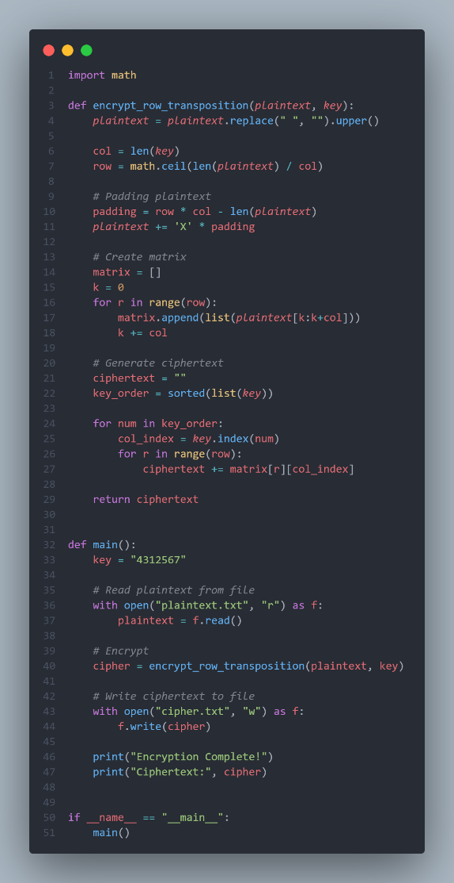
File Input & File Output
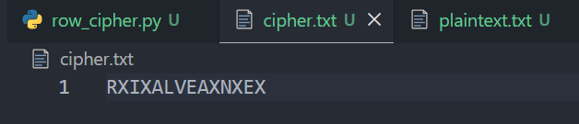

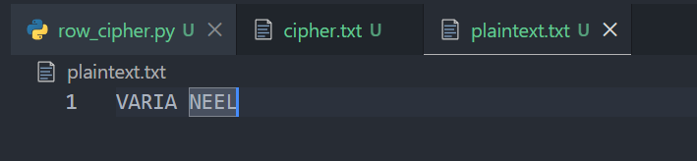

Terminal Output
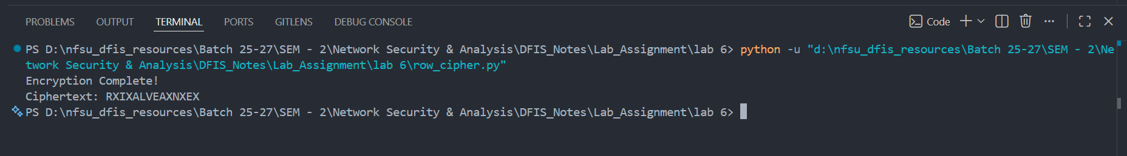

key = "4312567"

Assignment 2: Write a program to demonstrate Polybius Cipher
Take Plaintext input form File and Also Ciphertext store in File.

The Polybius Cipher is a classical substitution cipher that encrypts letters by replacing each letter with two numbers representing its position in a grid.
The cipher uses a 5 × 5 matrix of letters, where each letter is identified by its row and column number.

Example Table:
 | 1 | 2 | 3 | 4 | 5
1 | A | B | C | D | E
2 | F | G | H | I/J | K
3 | L | M | N | O | P
4 | Q | R | S | T | U
5 | V | W | X | Y | Z

Algorithm (Encryption)
- Construct a 5×5 grid with letters A–Z.
- Combine I and J in the same cell.
- Read the plaintext message.
- Convert text to uppercase.
- Replace J with I.
- For each letter:
  - Find its row and column in the grid.
  - Replace it with row number + column number.
- The sequence of numbers forms the ciphertext.

Code
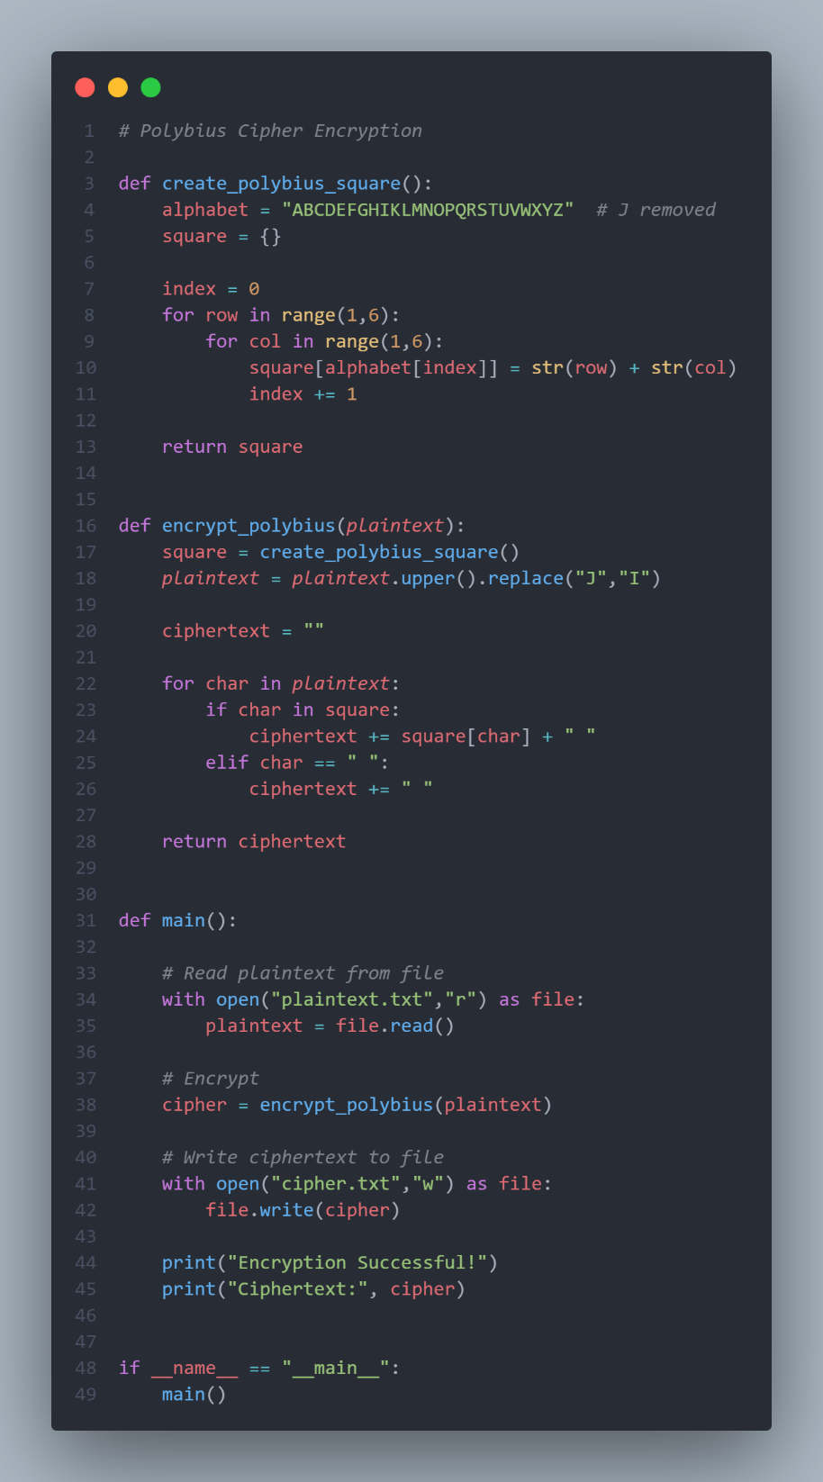
File Input & File Output
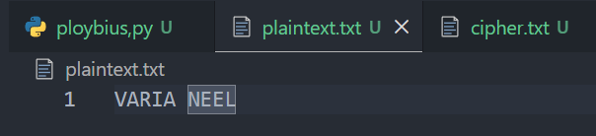

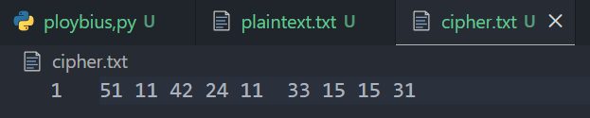

Terminal Output
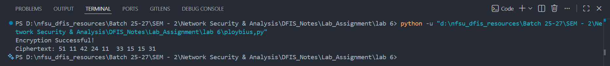

Assignment 3: Write a program to demonstrate the Rotor Cipher (as discussed in the classroom).
take the following inputs:
- Plaintext
- No. of rotor
- angle of each rotor

A Rotor Cipher encrypts text using multiple rotating substitution disks (rotors).
Each rotor shifts the alphabet by a certain amount (angle). The plaintext passes through each rotor sequentially, producing the ciphertext.

Example idea:
Plaintext → Rotor1 shift → Rotor2 shift → Rotor3 shift → Ciphertext

Algorithm (Working Steps)
- Take plaintext input from the user.
- Convert plaintext to uppercase.
- Take number of rotors (n).
- Take rotation angle (shift value) for each rotor.
- For each character in plaintext:
  - Ignore spaces or keep them unchanged.
  - Convert letter to its alphabet index (0–25).
- Pass the letter through each rotor:
  - Apply Caesar shift using rotor angle.
  - Result becomes input for the next rotor.
- After all rotors process the letter, convert it back to a letter.
- Append to ciphertext.
- Print the encrypted message.

Code
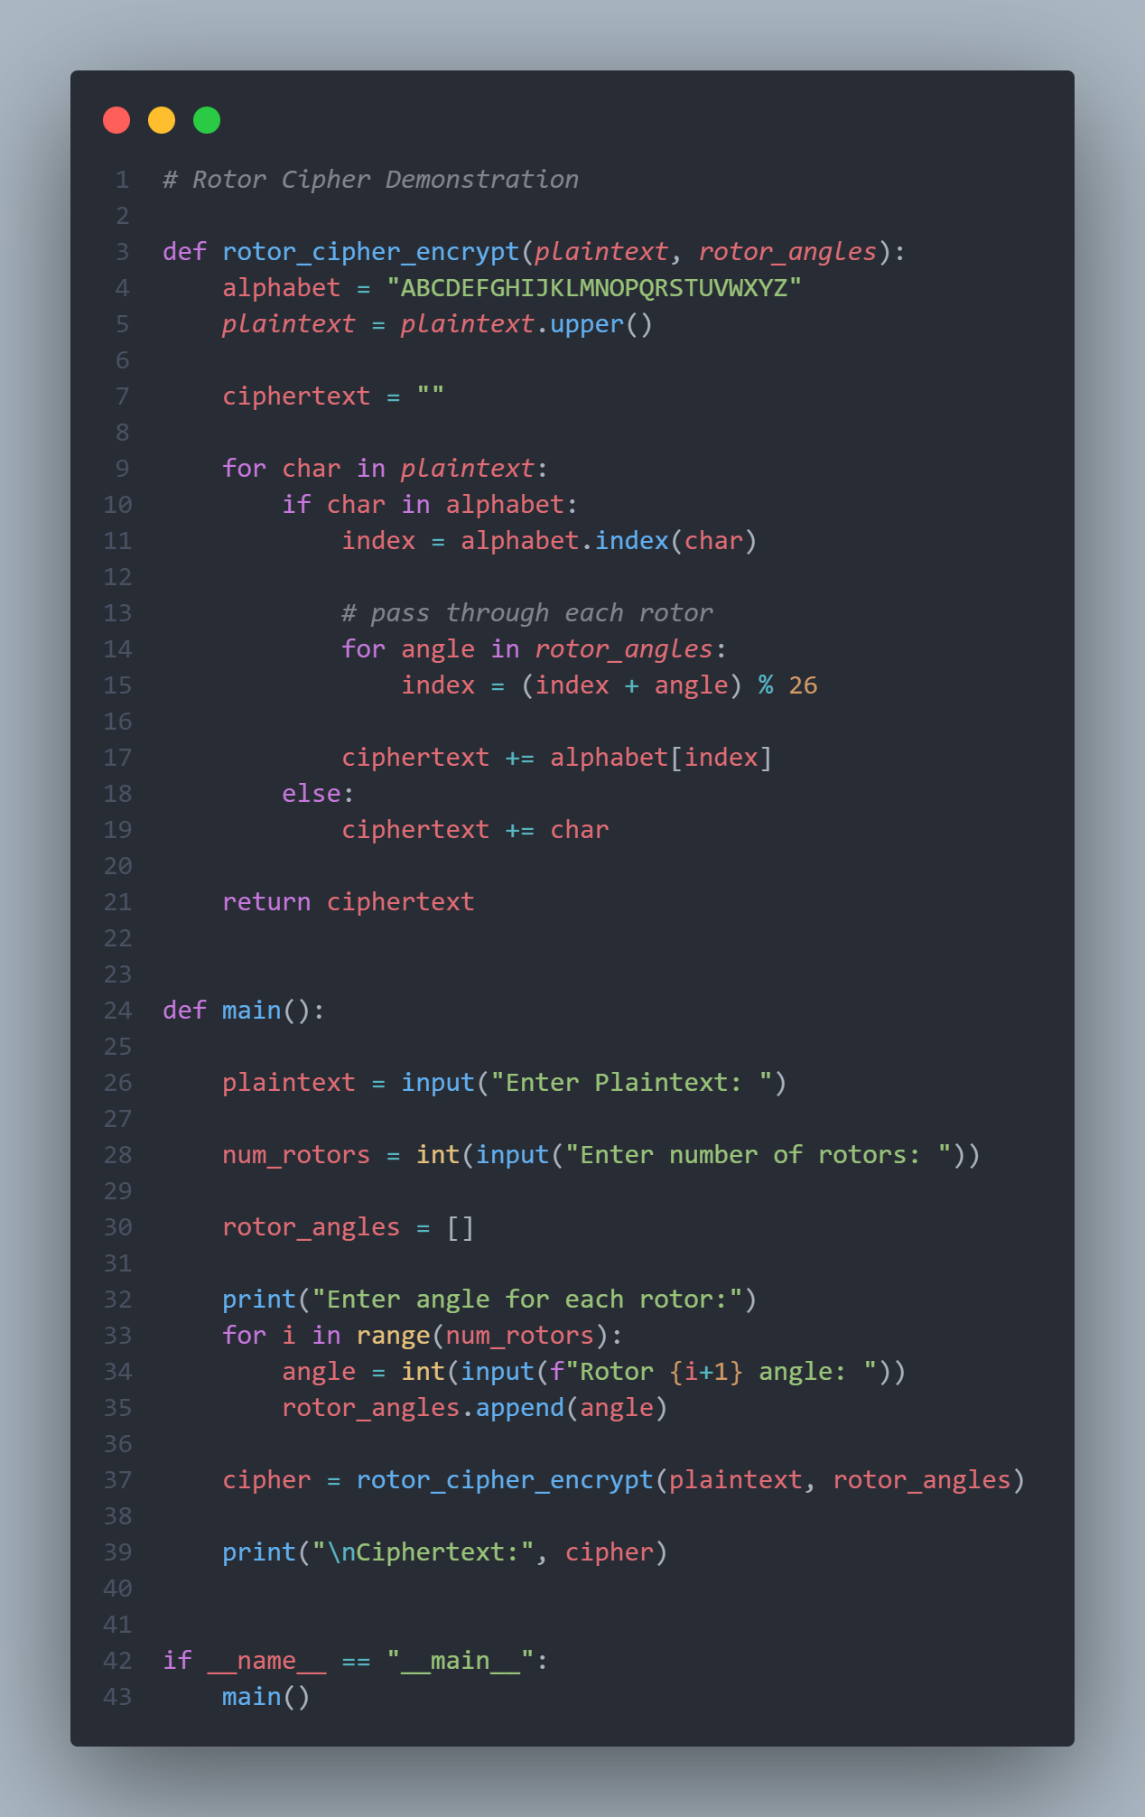
Example Execution
Input:
Enter Plaintext: HELLO
Enter number of rotors: 3
Rotor 1 angle: 3
Rotor 2 angle: 5
Rotor 3 angle: 2

Total shift = 3 + 5 + 2 = 10

Encryption:
Plaintext | Shift | Cipher
H | +10 | R
E | +10 | O
L | +10 | V
L | +10 | V
O | +10 | Y

Ciphertext: ROVVY

Now I am doing same with my name
